**Category**- Guest Post

**Main Keyword**: Restore Shift Deleted Items in Outlook 2010|2013|2016

**Note:** Keywords are highlighted in green throughout the article.

**Keywords Used:**

recover shift deleted files, recover shift deleted emails from outlook 2010, repair outlook file, fix outlook error, fix outlook file corrupted

**Learn How to Restore Shift Deleted Items in Outlook 2010/ 2013/ 2016**

Nowadays, all users prefer Outlook as their email client as it offers numerous features for their data management. Many times, while managing data, users delete their useful data items due to which they have to face problems later. At a cursory glance, it may seem impossible in the case of recover shift deleted files. In the following sections, will explain how to restore shift deleted items in Outlook 2010, 2013 and 2016.

**Need to Restore Permanent Deleted Data**

When an item is permanently deleted, we can use Outlook’s Recover Deleted Items folder to recover shift deleted from Outlook 2010. Most of the time, users have to delete confidential card information for security purposes. Accidental deletion is a frequent problem. Removal of files from the Deleted Items (trash) folder is also permanent deletion. Sometimes there is a need to fix Outlook error causing such problem. However the deletion, that data is very important and could be required right then or at a later date.

When the data is lost, we search far and wide to find a simple solution to recover shift deleted emails from outlook 2010 which is explained below.

**Methods To Restore Shift Deleted Items in Outlook**

In this section, we elaborate the steps to manually retrieve shift deleted files. The steps for Outlook 2010 are:

**Solution 1- Outlook Recovery Process for Shift Deleted Files**

Following are the steps to recover shift deleted Emails from Outlook 2010, and other files:

**Tip:** Always remember to obtain a backup of your data before performing any recovery operation. Following are the steps to recover your data using the Recover Deleted Items folder:

1. In MS Outlook, click ***Folder*** >> ‘***Recover Deleted Items’***.

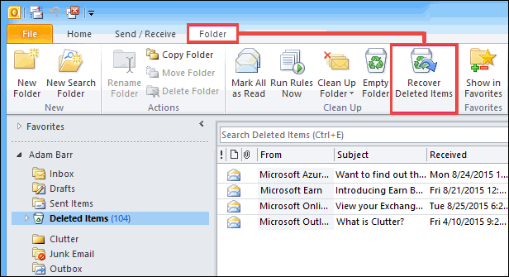

1. Find and mark the item(s) that you want to recover and click on ‘***Recover Selected Items’*** from the top menu.

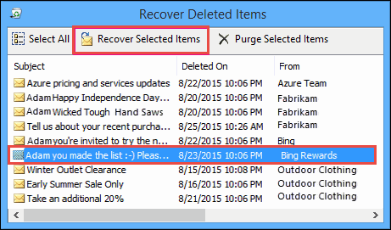

**Tip:** If the Recover Deleted Items folder contains a lot of mails, you can refine your search. Sort by clicking on Column names ‘Deleted On’, ‘Subject’ or ‘From’. The mail is sorted by the date when it was permanently deleted when using the ‘Deleted On’ sorting.

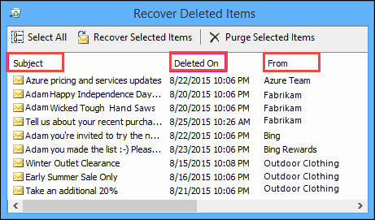

**For Outlook 2013 and Outlook 2016:**

The procedure for Outlook 2013 and Outlook 2016 is a little different and explained here:

1. Open Email Folders list, and select ***Deleted Items***.
2. Click on ***Home>>Recover Deleted Items from Server***.

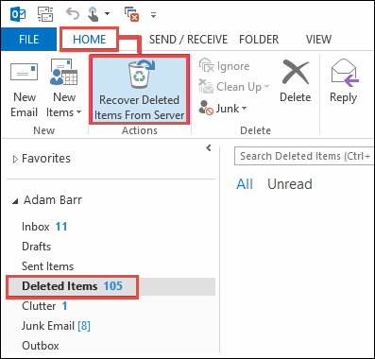

1. Select the list of items you want to retrieve, click on ***Restore Selected Items>>OK***.

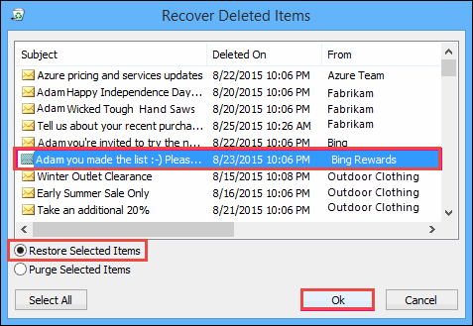

**Note**: Recovered items from the Recoverable Items folder go to the Deleted Items folder. So after an item is recovered, you can move it from **Deleted Items** to any other folder. The same is true for Contacts, Calendar and Outlook Tasks.

Limitations:

* There is a retention period for deleted items, after which that not recoverable. But, if you have been unsuccessful in finding the requested Contact/File, then they have been deleted forever.
* The manual approach would still not be able to fix corrupted Outlook file that caused Contact or email files and folders to be inaccessible.

**Solution-2 Outlook Web Access Option**

You can also try to recover your items using the Outlook Web Access using Exchange 2003 because it doesn’t need you to have a registry key.

1. Recovery of only Public Folders from mailbox can be achieved through the URL

***http://servername/exchange/alias/inbox/?cmd=showdeleted***

Login with your account and permit the ‘Full mailbox access’. From the list of deleted items, select all files you want to recover.

1. To recover Public Folder items, the URL will be ***http://servername/public/rootfolder/subfolder/?cmd=showdeleted***

“servername:” Exchange server's name.

“path”: path to the parent of deleted folder.

Select the deleted folder and recover it. Remember to always close your browser and OWA after this to protect sensitive information.

Limitations of the Manual Approach:

* If the administrator has not configured Exchange Server settings, the Recover Deleted Items functionality will not be available by default for any folders in Outlook.
* Without a registry key (Dumpster.reg), the Web Access method will not be able to recover private folders.

The most appropriate solution would be to use a dedicated tool that can restore permanently deleted files and repair Outlook file for a complete problem resolution.

**Reliable Solution**

The manual recovery of permanently deleted Outlook files is time-consuming and often unsuccessful. However, there is an **Outlook Recovery Tool** that is adept at file recovery. This automated tool can restore Contacts, Emails or folders even though it is past their retention period. Let’s look at some of the attributes of this tool:

Characteristic Features

* **Recover deleted data**: Using this tool, users can restore the shift deleted emails or other files. Moreover, the tool allows the user to recover deleted items from a corrupt .pst file using Advance Scan.
* **Export recovered data in multiple formats**: The tool gives the user an option to save the recovered Outlook file in the file format of their choosing. It can be either .pst, .eml or .msg depending on their needs and requirement. Using Mail Filter, you can select emails from one date to another.

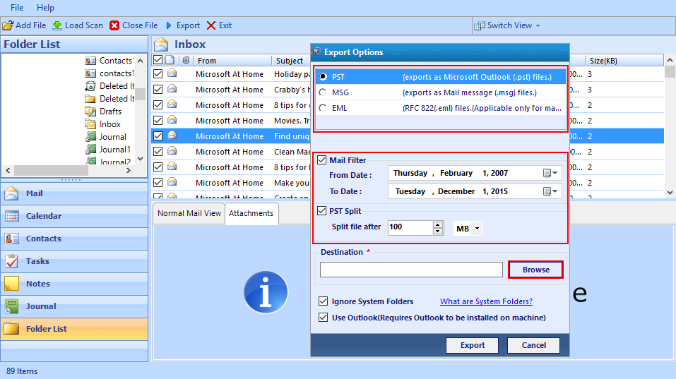

* **Split resulting file into smaller PST:** The larger files are split into smaller .pst files for ease of access. The user can specify in MBs the size according to which the split is required.
* **Ensures data integrity:** When Outlook folders and files are restored, they maintain their integrity. They are recovered as is, without any data loss.

This is what makes the tool indispensable for any user looking to recover permanently deleted data. It is quick, efficient, and complete in itself. It can become your go-to procedure for swiftly restoring deleted data.

**Conclusion**

After understanding the need of the users, we know that data plays the most important part. Various methods have been discussed in this article on how to restore shift deleted items in Outlook 2010, 2013 and 2016. Users can choose according to their needs if they want to manually recover shift deleted files or use the Outlook Recovery Tool. If you face any issues during the restore process, you can leave a comment with your query and we will respond with a solution.